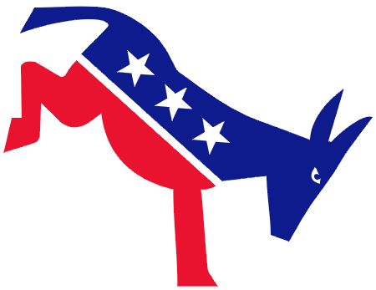
Castro Valley Democratic Club (FPPC #930572) 2022 Membership Form

First Name: _______________________________ Last Name: ______________________________________
Street Address: _______________________________ City: ______________________ Zip Code: _____________
List each Individual Member’s or Household Members’ contact information:
First Name | Last Name | Mobile Phone | Email

2022 MEMBERSHIP DUES are payable by January 1, 2022
☐ Individual Membership $20 Contribution: ☐ $25 ☐ $50 ☐ $75 ☐ $100 ☐ Other____
☐ Household Membership $25
☐ Sustaining Membership $100
☐ Student Membership $10
TOTAL AMOUNT: __________

PAYMENT BY MAIL
Fill out form and mail with check or money order, payable to “Castro Valley Democratic Club.”
Castro Valley Democratic Club
PO Box 2173
Castro Valley, CA 94546

PAYMENT BY PAYPAL

To donate by PayPal, go to https://www.paypal.com/donate/?hosted_button_id=HUJAYX3F6UBT2
Then email Membership Form to Membership: cvdemsclub@gmail.com

